**MW Bevel Tool Problems and Solutions**

# The “vertex face” problem.

**Solution**:

* Remove the object’s edges from bevel set;
* Delete the object’s construction history;
* Add the object’s edges into bevel set again.

This problem only occurs in Viewport 2.0 mode.

# When does the bevel tool display the intermediate object?

**Solution:**

The tool displays an object’s intermediate when the user select an object and its select type is edge. The tool controls the display of intermediate by using three selection event callbacks: **“SelectionChanged”, “SelectTypeChanged” and “SelectPreferenceChanged”.**

**“SelectionChanged” event.**

Left clicking an object triggers this event because the selection list is changed.

**“SelectTypeChanged” event.**

Switching selection type from one type to another by right clicking an object triggers this event. Right clicking an object without left clicking it first doesn’t trigger “SelectionChanged” event.

**“SelectPreferenceChanged” event.**

Switching selection mode from component to object triggers this event instead of “SelectTypechanged”.

The tool only processes the last selected object and display a warning message if you switch more than one objects’ selection type to edge.

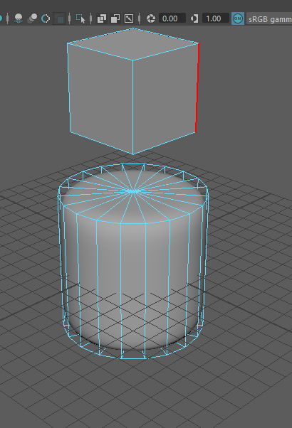

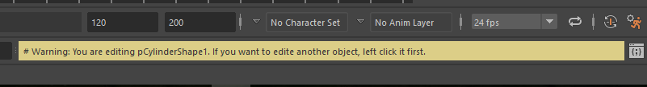

# 3 What if the user modify the object when the bevel tool is opened?

**Solution:**

The user is forbidden to modify the intermediate.



The tool delete the object’s construction history automatically when the user

modify the original object.